Student Name: NANCY SARANGE MAINGA
Admission Number: BIT/2025/32683
School Faculty: Computing And Informatics
Programme: Mobile Application and Development
Academic Year:3
Semester: 2
Lecturer: M Nyoro
Phone Number:0112127599

TASK 1
Installed Android Studio and set up the SDK.
- Java Development kit
Version: java -version
Status: installed and working
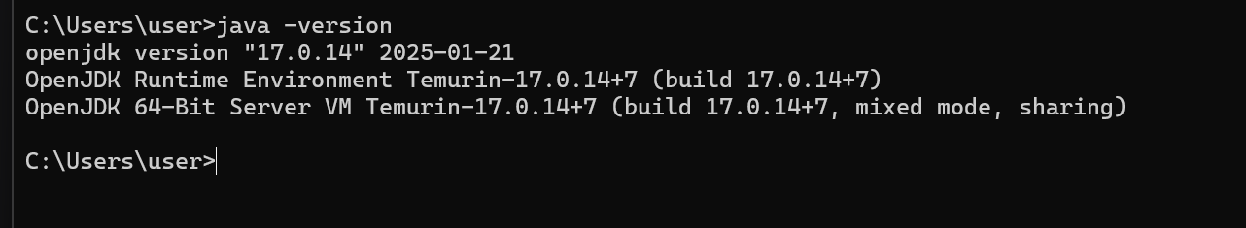
- Node .js
Version: node –version
Status: installed
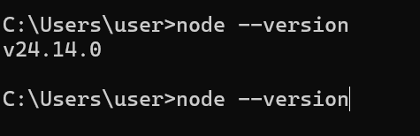
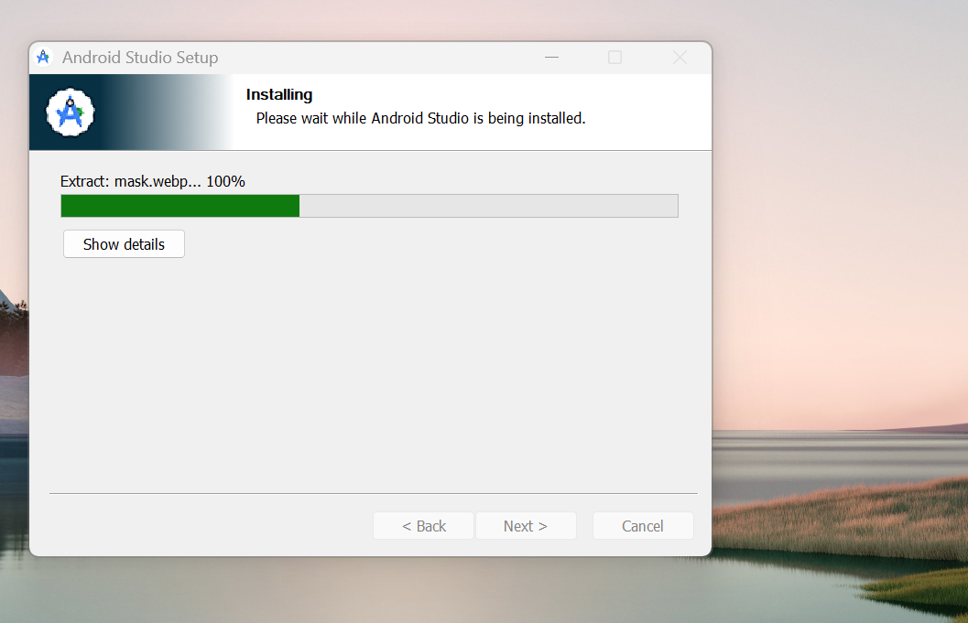

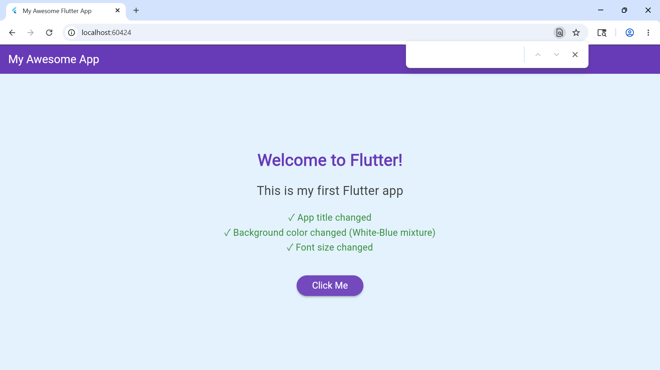
TASK 2
Installed Node.js, Expo CLI, and Expo Go
Created a new React Native project using npx create-expo-app
Ran the app on my phone via Expo Go S(QR code scan)

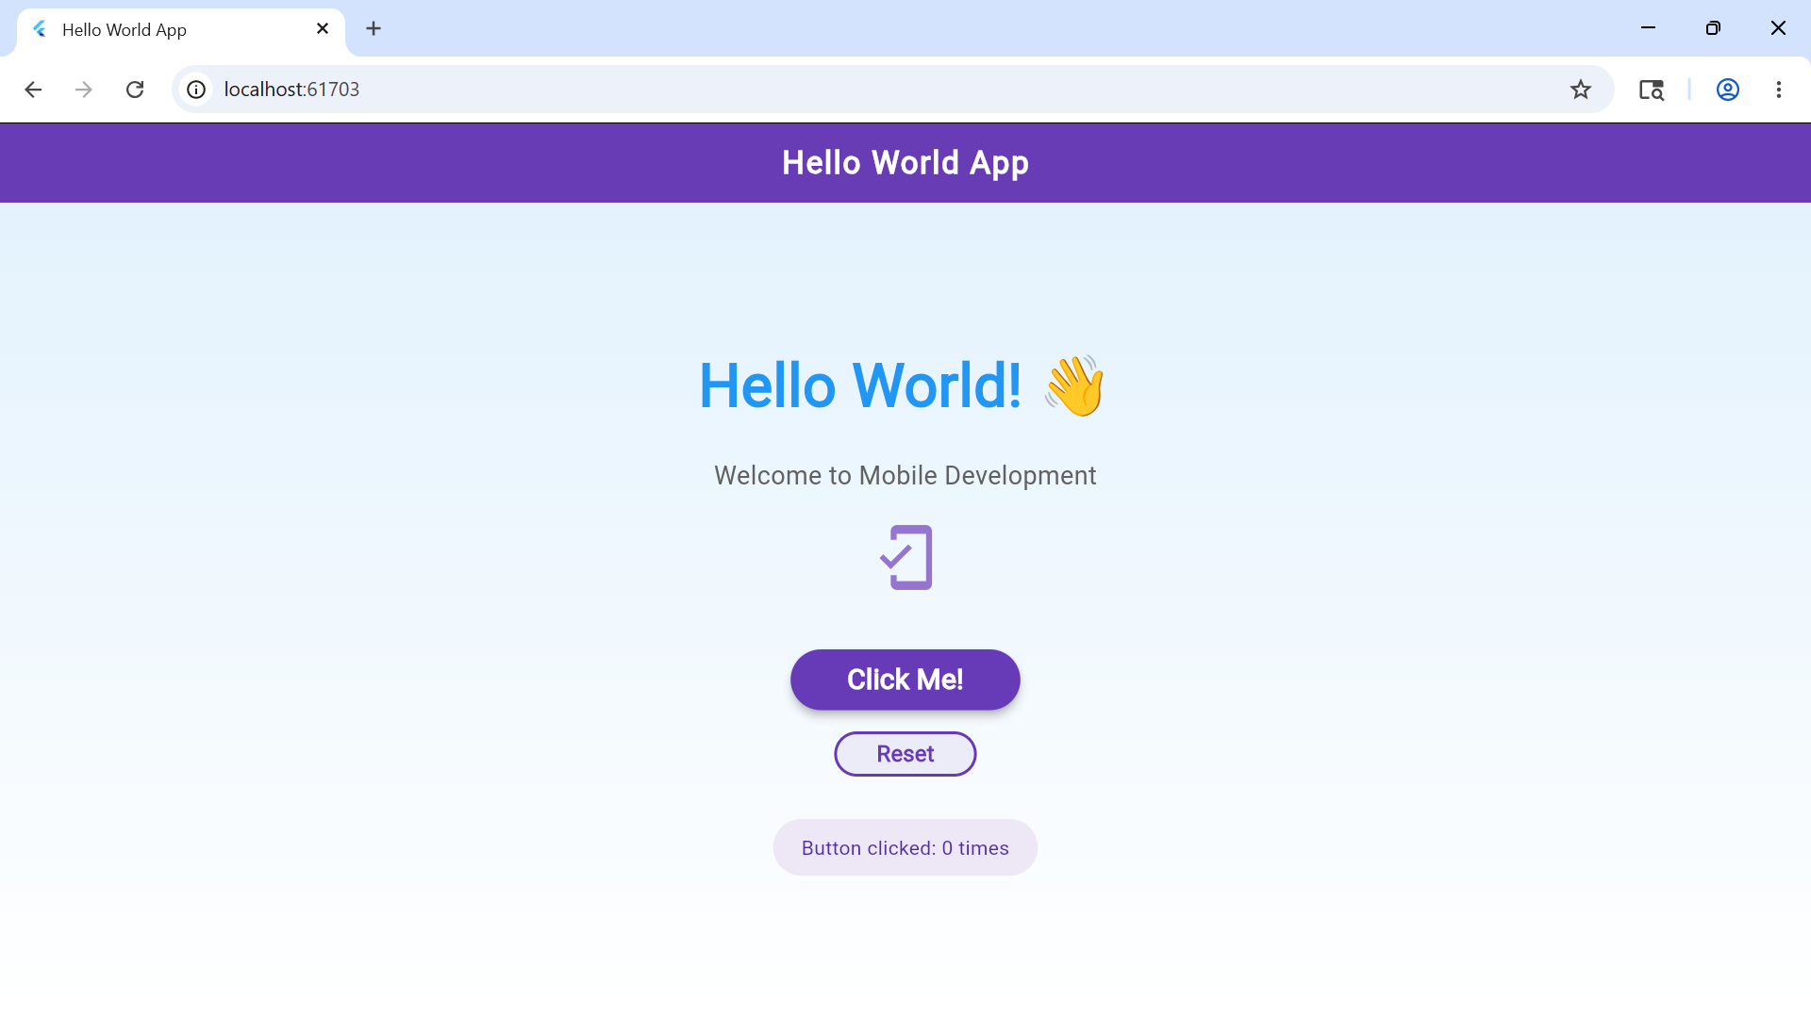
FIGURE(a)
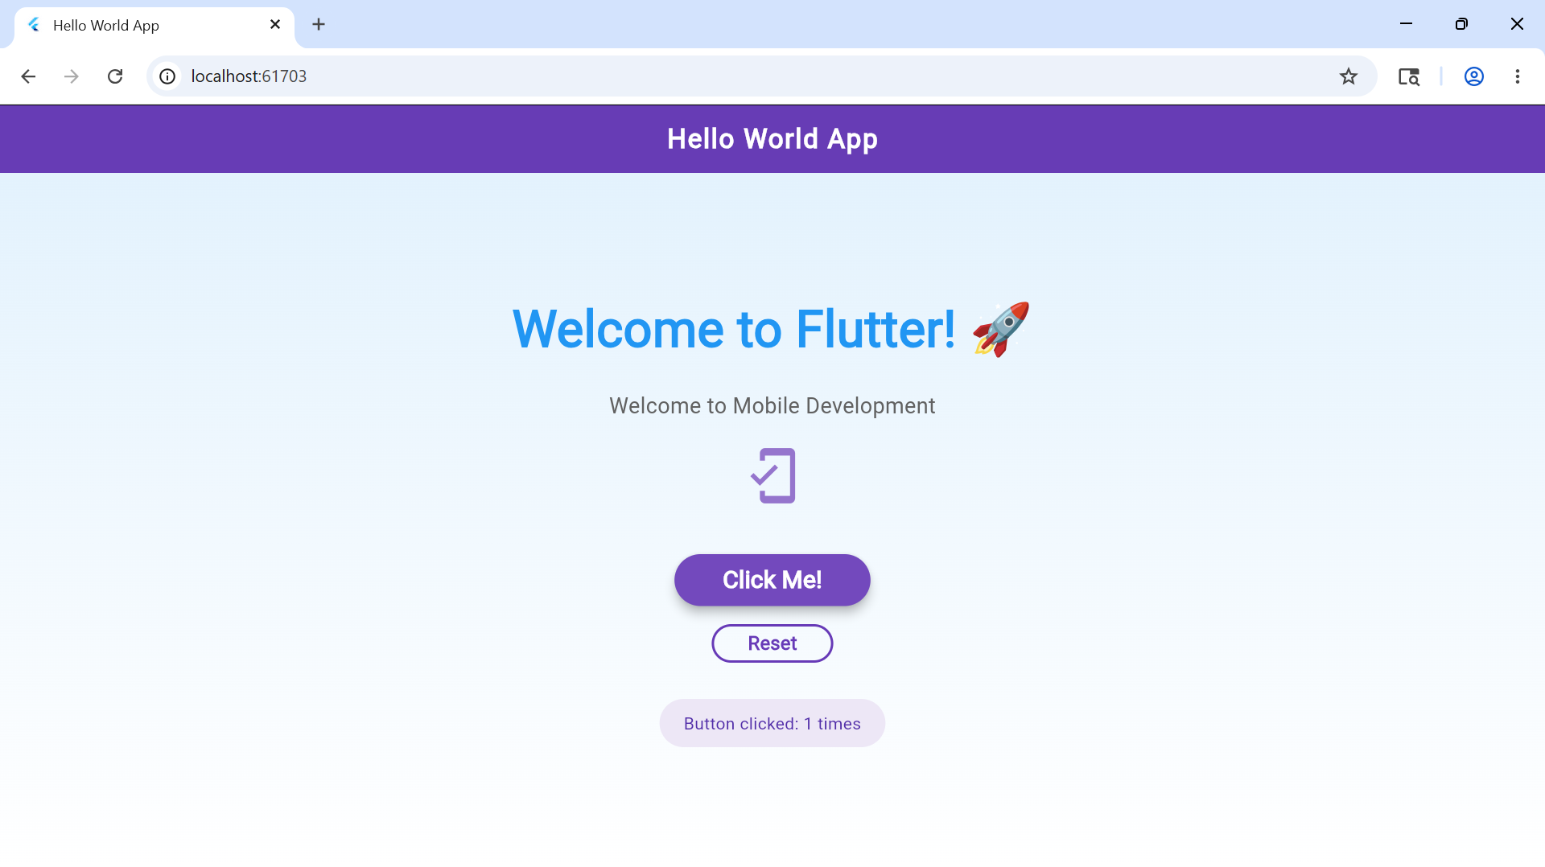
FIGURE (b)

Personal Reflection
Setting up Expo was faster than native Android. Running the app instantly on my phone via QR code was impressive

Student Mini Management APP
Installed @react-native-async-storage via Expo
Created a simple form to add student name, registration number and course
Implemented save, view and delete functions
Add new students
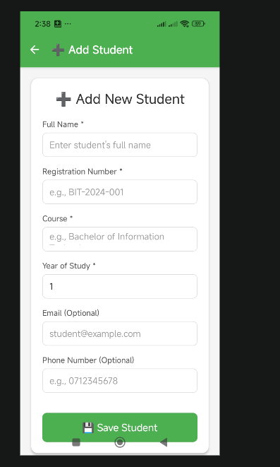
Edit students
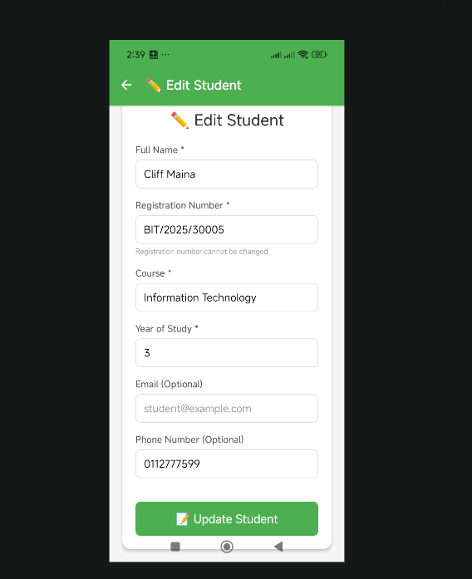

Student records
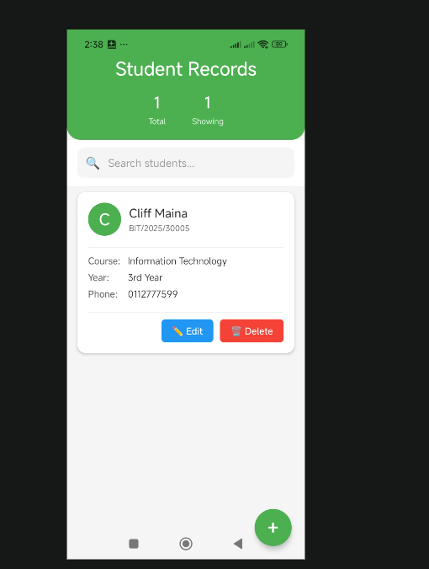
Personal Reflection
AsyncStorage is straightforward for small datasets. My student records now persist locally

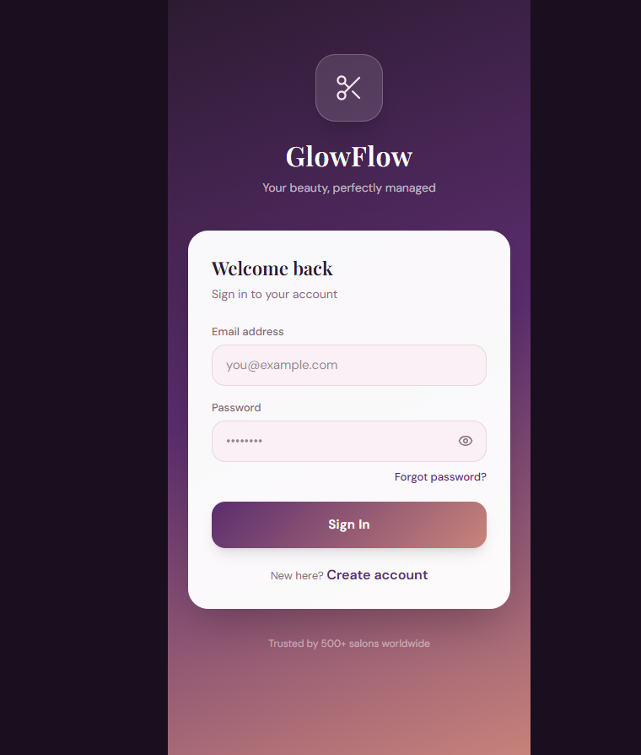

HOME PAGE
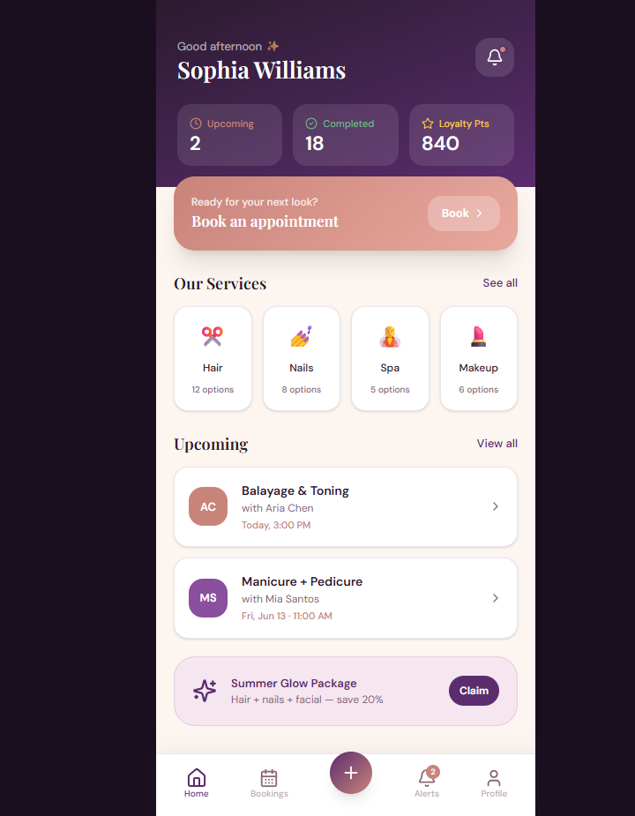

BOOKING PAGE
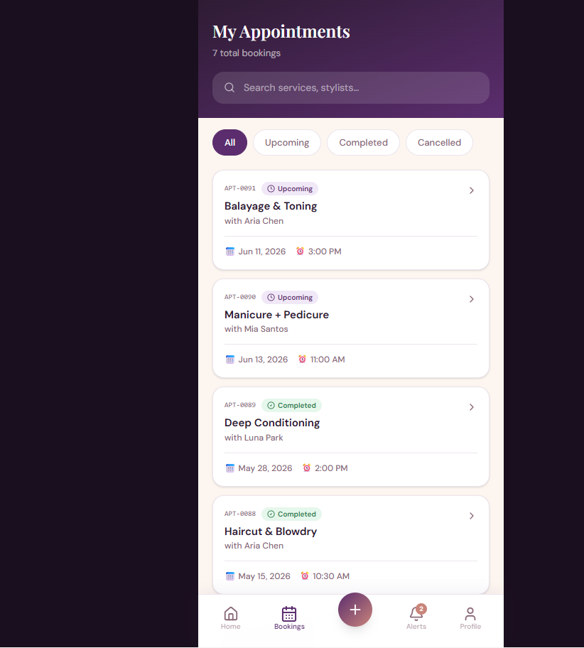

NOTIFICATION PAGE
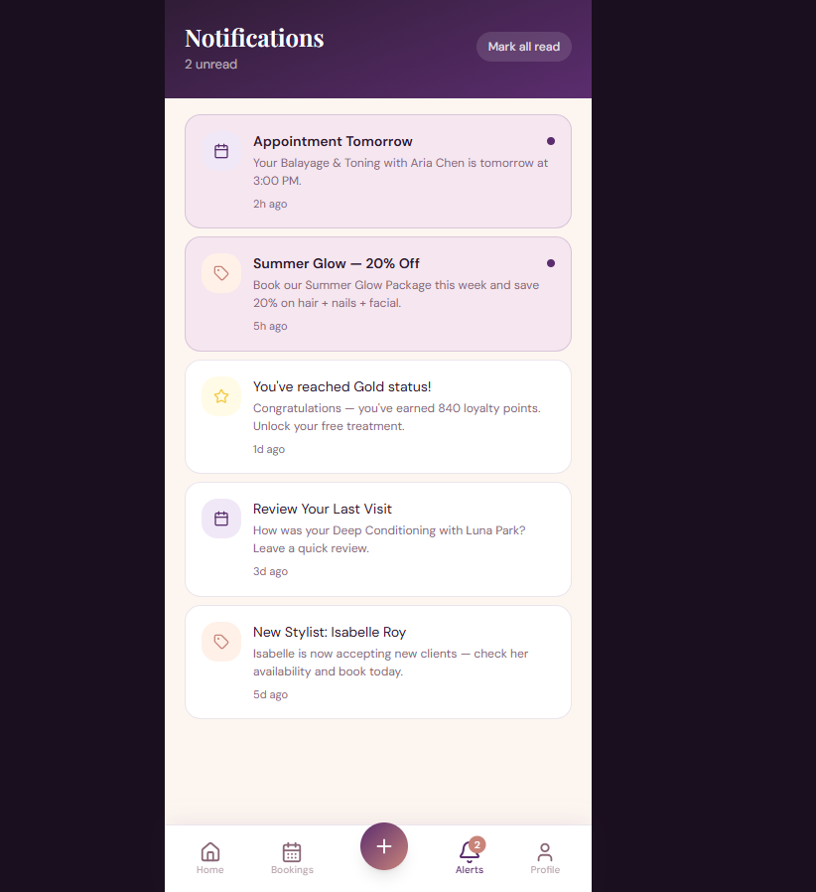
PROFILE PAGE
